Title of the portrait  Artist name  Rita Quattrocchi | Paste in the image you are analyzing  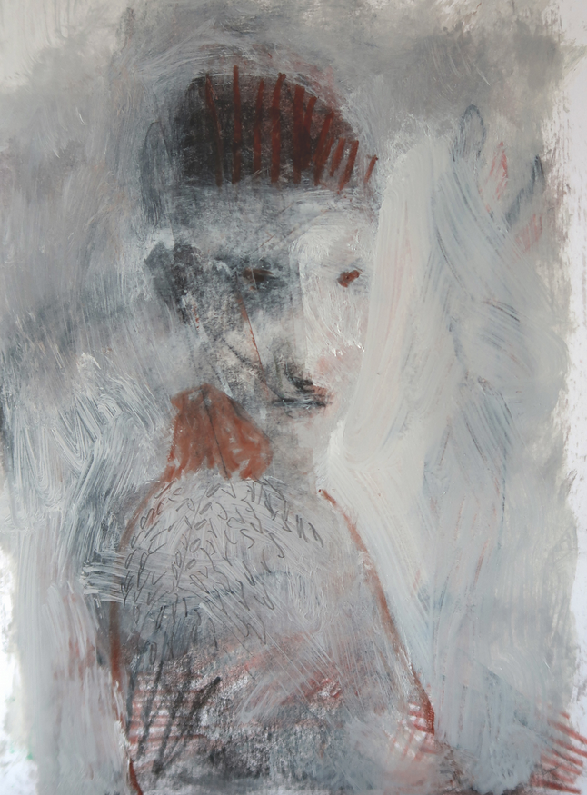
ㅡ  Why did you select it? | The style of this portrait is unique. As the figure is not clearly defined but has a melancholy look. The author has boldly used a mixture of gouache, oil pastel and pencil to express the texture, and the textures have been carefully arranged to maintain the balance of the image.
ㅡ  Theme and Tone | This painting gives me a quiet but depressing feeling, probably because of the overall grey tone of the picture and the dark red shadows that create a sense of closure.
ㅡ  Technique | The artist has his own understanding of the composition of the face of the figure, so that the facial form of the figure does not look like that of a regular sketch. The author has deliberately exaggerated the shape of the face, such as elongating the face and narrowing the eyes, to give the figure a soul and character (more melancholy). The author's use of color is also very clever, as he uses few colors but differentiates the sketching relationship properly, with only three colors - red, grey and black - explaining the whole picture.
ㅡ
Last thoughts
 | I think I would recommend it to other people because everyone will have a different interpretation of such a emotionally charged painting. I interpret it as sad and depressing but perhaps others will feel at peace with it. I also like the artist's other work, the bold gouache painting of the backgrounds and the characterization are the building blocks for the accumulation of emotional expression.

6 words to describe: stream-of-consciousness illusory peaceful informal natural abstract

